**Table of Figures**

Figure 1: Configuring private network for vagrant box 2

Figure 2: Configuring public network for vagrant box 2

Figure 3: Insallation of apache and nginx 3

Figure 4: ifconfig 3

Figure 5: /etc/nginx/sites-available/example 4

Figure 6: /etc/apache2/ports.conf 4

Figure 7:/etc/apache2/ports.conf 4

Figure 8: Running both apache and nginx at same time with different port 5

Figure 9: Installing mysql database 5

Figure 10: Grant Permissions 6

Figure 11: Running mysql database 6

Figure 12: Configuring a user and password for a specific user and pwd. 7

Figure 13: Port checking 7

**Vagrant virtual box having private and public network which can be accessed from local machine**

#Author: Anikit Shahi

#Date: 11/3/2021

To have a private and public network accessible from our local machine in the Vagrant virtual box, we must perform the following:

**Step 1**: Configure both private and public network for vagrant box.

We need to make a few changes to the vagrant file, as shown below, to configure both the private and public networks.

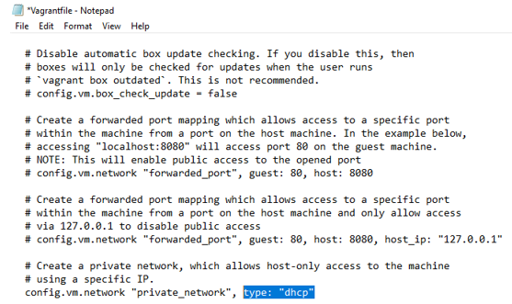

Figure 1: Configuring private network for vagrant box

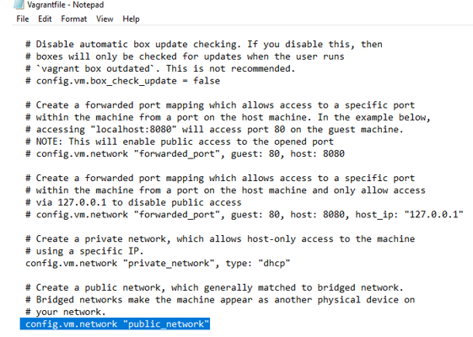

Figure 2: Configuring public network for vagrant box

**Step 2**: Install apache and ngnix web server both at same time with different port and must run on background and also restart if there is any process failure.

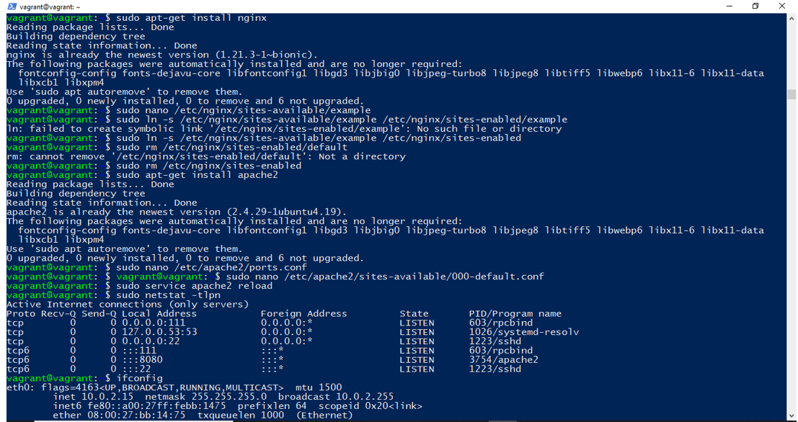

Figure 3: Insallation of apache and nginx

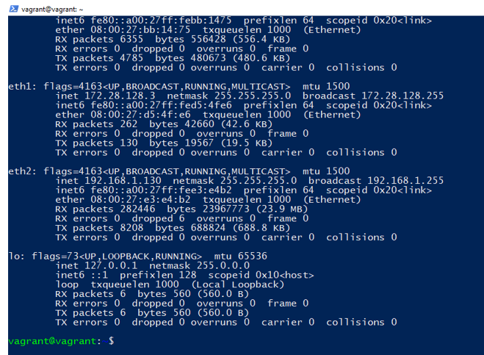

Figure 4: ifconfig

We need to give distinct ports to apache and nginx in order to run them both at the same time. Inside these followings, we need to do certain changes.

* /etc/nginx/sites-available/example
* /etc/apache2/ports.conf
* /etc/apache2/sites-available/000-default.conf

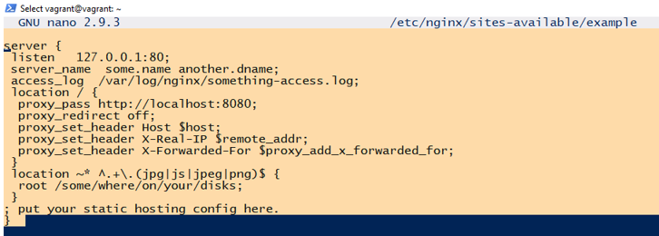

Figure 5: /etc/nginx/sites-available/example

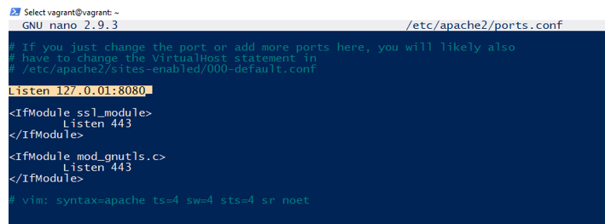

Figure 6: /etc/apache2/ports.conf

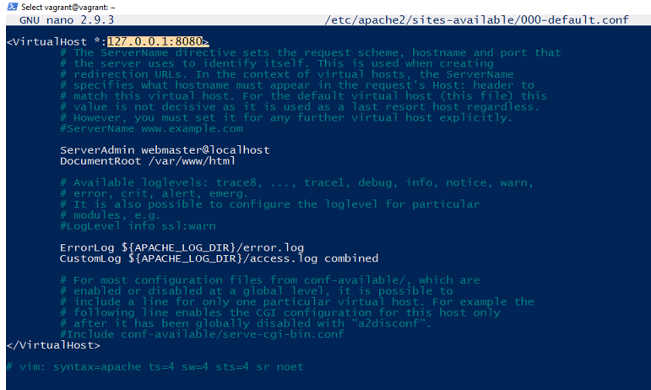

Figure 7:/etc/apache2/ports.conf

**Step 3**: Checking the status if it is running or not from systemmd.

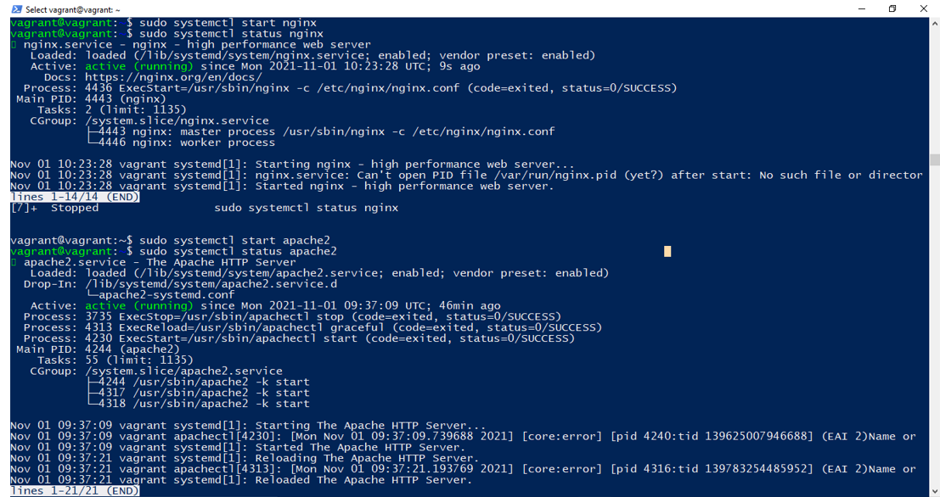

Figure 8: Running both apache and nginx at same time with different port

**Step 4**: Install mysql database in vagrant box and configure a user and password for a specific user and pwd.

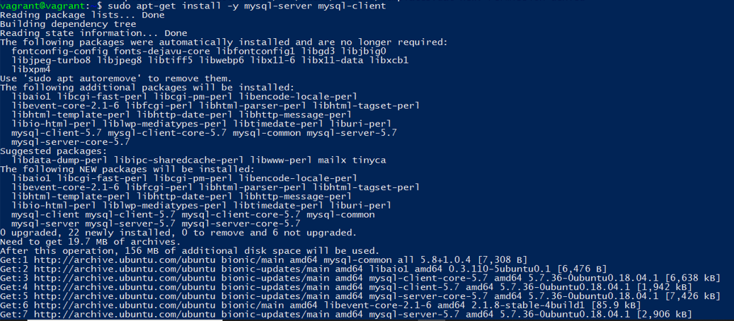

Figure 9: Installing mysql database

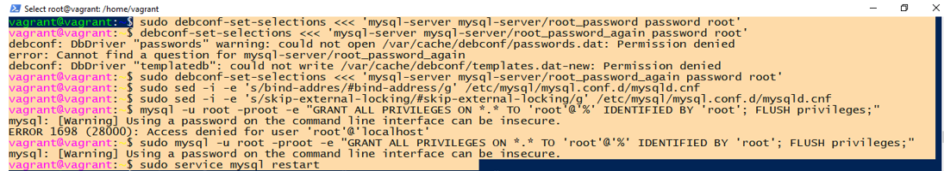

Figure 10: Grant Permissions

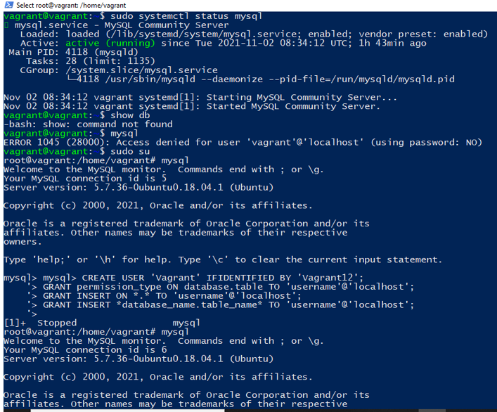

Figure 11: Running mysql database

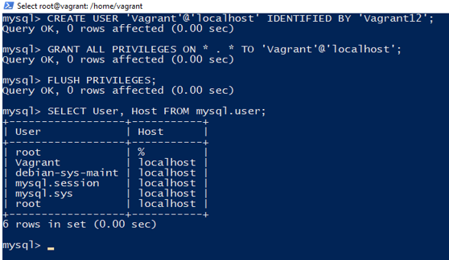

Figure 12: Configuring a user and password for a specific user and pwd.

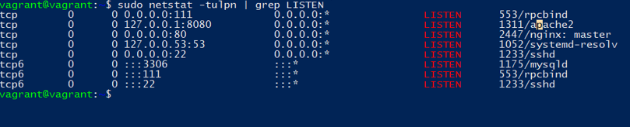

Figure : Port checking